**DAILY ONLINE ACTIVITIES SUMMARY**

|  |  |  |  |  |  |  |  |  |
| --- | --- | --- | --- | --- | --- | --- | --- | --- |
| **Date:** | 20-06-2020 | | | | | **Name:** | Anvitha H M | |
| **Sem & Sec** | 4th ‘A’ | | | | | **USN:** | 4AL18CS010 | |
| **Online Test Summary** | | | | | | | | |
| **Subject** | | Data communication | | | | | | |
| **Max. Marks** | | 30 | | **Score** | | | 26 | |
| **Certification Course Summary** | | | | | | | | |
| **Course** | Introduction to information security. | | | | | | | |
| **Certificate Provider** | | | Great learning academy | | **Duration** | | | 7 hours |
| **Coding Challenges** | | | | | | | | |
| **Problem Statement:** Java program to count number of bits to be flipped to convert A to B. | | | | | | | | |
| **Status:** Executed | | | | | | | | |
| **Uploaded the report in Github** | | | | | YES | | | |
| **If yes Repository name** | | | | | <https://github.com/alvas-education-foundation/Anvitha-H-M> | | | |
| **Uploaded the report in slack** | | | | | Yes | | | |

**Online test:**

The online test was on module 3 and 4 which was all of objective type. The questions are optimal and easy. There were 30 questions for 30 minutes. The score that I got was 26/30.

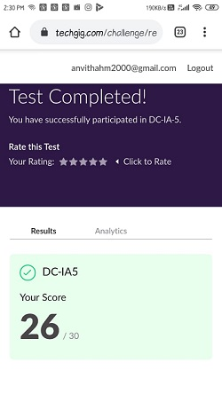

**Certification course:**

Introduction to information security.

The course includes detailed explanation on security lessons from big name breaches and code emerging trends in cyber security.

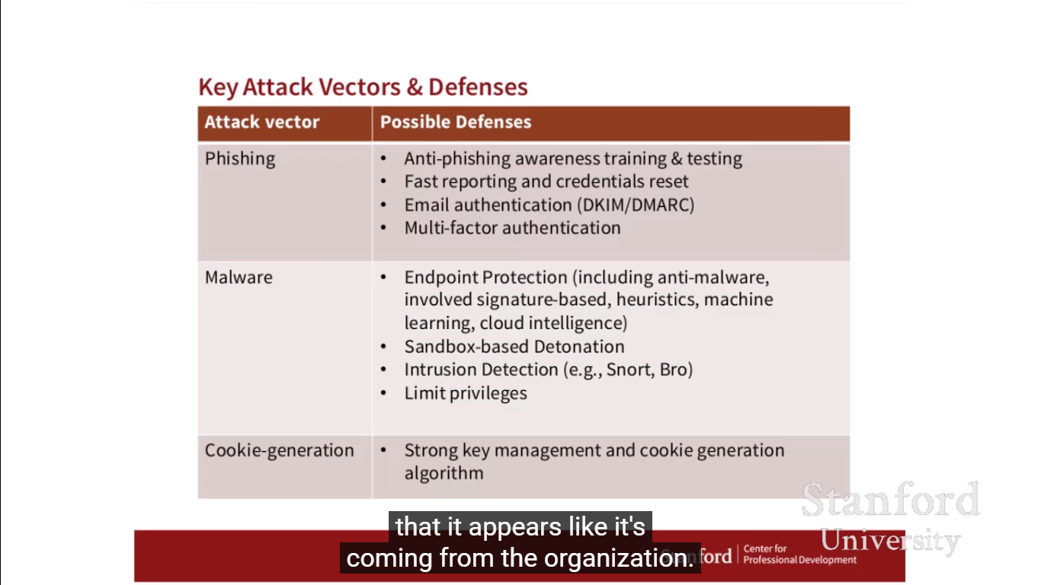

Online coding challenge

The programing statement of the day is

“Java program to count number of bits to be flipped to convert A to B.”

Solution: Executed and uploaded in Github repository.

Link: <https://github.com/alvas-education-foundation/Anvitha-H-M>

